

Sprint 4 - User Stories & Wireframes

Contents
Changes-Lease deed 3
Changes-Mutation 3
User Stories- Lease Deed Process 3
1. User Story- Generate Property Checklist 3
1.1 Mock-ups 6
2. User Story- Add Lease Deed Details 8
2.1 Mock-ups 10
3. User Story- View Lease Deed Details 12
3.1 Mock-ups 13
4. User Story – Generate Lease Rent Challan 15
4.1 Mock-ups 16
User Stories- Mutation Process 20
1. Add Mutation Request 20
1.1 Mock-ups 22
2. View Request- Department User 25
2.1 Mock-ups 26
3. Cancel Mutation Approval request 30
3.1 Mock-ups 30
4. View Comment- Department User 33
4.1 Mock-ups 34
5. View Request- Approver 35
5.1 Mock-ups 37
6. User Story- Approve/Reject Mutation approval Request 41
6.1 Mock-ups 43
7. Resubmit request for Mutation Approval 45
7.1 Mock-ups 46
8. View Comment- Approver 47
8.1 Mock-ups 48
9. Generate Mutation Letter 49
9.1 Mock-ups 50
10. SMS/Email Notifications to allottee 51

Changes-Lease deed

S NO | MODULE | DESCRIPTION | Date
1 | 1,2,3 | Added fields for company | 10/07/2016
2 | 2,3 | Upload lease deed functionality | 10/07/2016
3 | All | Changed Mockups and User Stories | 05/07/2016
4 | 5 | Removed User Story for Lease Rent Calculation | 05/07/2016
5 | All | Changed all mockups and user stories | 27/06/2016
6 | 1,4,5 | Changed entire user stories and mockups. | 25/06/2016
7 | 1 | Removed BR | 25/06/20116
8 | 2 | Updated BRs | 25/06/20116
9 | 1 | Updated the user stories of generate checklist, Add and View lease deed details. | 25/06/20116
10 | All | Mockups Updated for:  Generate Lease deed  Add Lease deed  View Lease deed  Updated Manage Lease deed grid.  Lease Rent menu page. | 25/06/20116
11 | 4 | Removed functionality of Lease rent Schedule | 25/06/20116
12 | All | Changed the order of the menus and user stories. | 25/06/20116

Changes- Mutation

S NO | MODULE | DESCRIPTION | Date
1 | 1,2,5 | Added fields for company | 12/07/2016

User Stories- Lease Deed Process

User Story- Generate Property Checklist

Sprint | 4
User Story ID | 001
User Story Title | Generate Property Checklist
Actors | Department user
Story | As a department user, I want to generate checklist for particular department and property type.
Pre Conditions | - User should have required access rights.  - Printer should be connected to the LAN.
Business Criteria | - If there is no change in the "Checklist Date" value for the same Rid and checklist type, no changes will be made in the already existing record in database. No Audit Trail changes will be made in this case.  - "Generate Checklist" button will still appear in the cases where Checklist has already been generated.  - Checklist would be in the form of "Intimation Letter”. It will be a letter containing some textual content, followed by checklist.
Acceptance Criteria | - User would click on “Checklist” from the navigation panel and would get a form.  - User would then select “RID” from the dropdown and below fields would be displayed under “Allottee Details” section:  - Allottee Name: Label  - Signing Authority: Label (in case of company as gender)  - Registered Office: Label (in case of company as gender)  - Father Name: Label  - Department: Label  - Property Type: Label  - Property Number: Label  - Property Cost: Label  - Allotment Money: Label  - Allotment Date: Label  - Checklist Due Date: Label  - User would then update the following fields from dropdown available under “Select Checklist” section:  - Checklist Type: Dropdown, mandatory  - Checklist Date: Date picker, mandatory  - User would click on “Generate Checklist” button. The system would then generate and display the checklist on the application screen.  - User would print checklist by clicking on ‘Print’ button.  - The options available in “Checklist Type” dropdown would be from checklist type table in database.
Field level Validation

Mock-ups
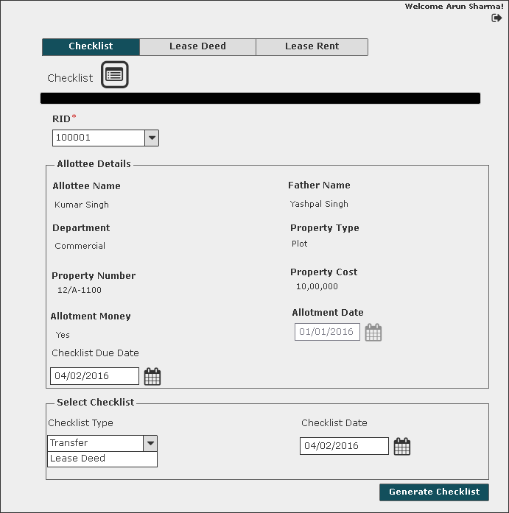

User Story- Add Lease Deed Details

Sprint | 4
User Story ID | 002
User Story Title | Add Lease Deed Details
Actors | Department user
Story | As a department user, I want to add lease deed details for a property in system.
Pre Conditions | - User should have required access rights.
Business Criteria | - User would be able to add lease deed entries only for his department.  - For a property Lease deed would only added, if checklist has already been generated for the property.  - Lease deed would only be executed for allotted properties.  - There would be only one lease deed entry per Registration Id.  - It is mandatory to provide at least two witness details as per the current rule by the Authority.  - Lease deed would only be executed if allotment money is paid.  - Lease deed would only be executed if there are no dues till date.  Calculate outstanding payment at any point of time against a payment schedule  Dues are calculated e.g., if an instalment is missed, it is marked as dues. Penal interest is applicable on dues  In case customer pay partial amount before due date of next instalment then, reconciliation takes place and penal interest is applicable  - Till date on the amount dues.  - Up to the due date for next instalment, on dues remaining (dues minus partial payment)  In case customer pays amount on due date then reconciliation takes place on due date.  Penal Interest = P*(1+r/100) ^ n  Where,  P = Principal  r = rate of interest  n = frequency  - Lease rent would start after the successful completion of lease deed.  - The rate of the lease deed stamp value will be charged as per selection of stamp duty.  - Upload Lease deed functionality would be in integration with DMS.
Acceptance Criteria | - User would click on “Add Lease Deed” button under the lease deed menu.  - User would get a form with label as “Add Lease Deed”. User would then select “RID” from the dropdown and would be displayed with below fields:  - Allottee Name: Label  - Father Name: Label  - Signing Authority: Label (in case of company as gender)  - Registered Office: Label (in case of company as gender)  - Department: Label  - Property Type: Label  - Property Number: Label  - Property Cost: Label  - Stamp Duty Amount (INR): Label  - Duplicate Stamp Value: Label  - Previous Dues (INR)  - Balance Due till date  - Registry Type: Label  - Lease Deed Due Date: Label  - Lease Deed Execution Date: Date picker, mandatory.  User would update the following fields for the selected registration ID.  - lease deed execution date, mandatory  - Signatory Authority: Textbox ,mandatory  - User would add witness details. User can add up to four witnesses, for each witness following fields would be displayed:  - Name: Textbox  - Address: Text Area  - Mobile No: Textbox  - User would upload lease deed scanned image under upload lease deed option.  - User would click on the “Add” button to execute lease deed for a property. On successful submission a message as “Lease deed details added successfully” would be displayed. The details would be displayed in grid on “Lease Deed” screen. Alternatively, on clicking the “Back” button system would return the user to the lease deed screen without saving the details.  - Grid will display following columns:  - RID  - Scheme  - Department  - Stamp Duty Amount  - Lease Deed Due Date  - Lease Deed Execution Date
Field level Validation | - Signatory Authority: Maximum 100 Characters  - Name: Maximum 100 characters  - Address: Maximum 200 characters  - Mobile No: Fixed 12 characters, only numeric  - Upload Lease deed: maximum file size 100kb. (jpg,png)

Mock-ups

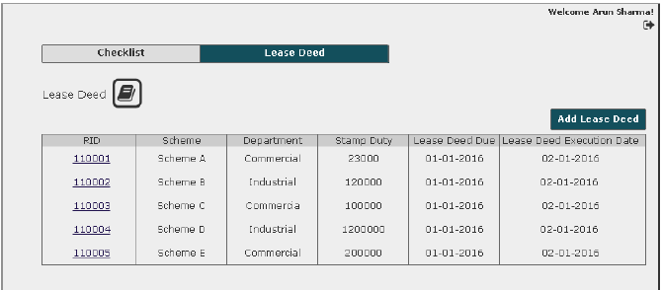
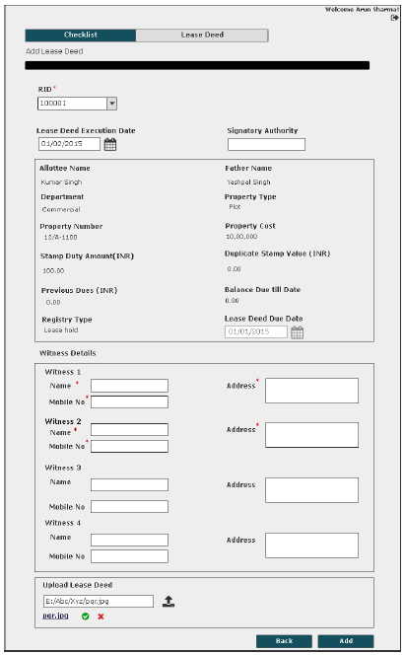

User Story- View Lease Deed Details

Sprint | 4
User Story ID | 003
User Story Title | View Lease Deed Details
Actors | Department user
Story | As a department user, I want to view lease deed details.
Pre Conditions | - User should have required access rights.
Business Criteria | - View Uploaded Lease deed functionality would be in integration with DMS.
Acceptance Criteria | - User would click on “RID” hyperlink option available in grid for viewing the lease deed details.  - User would get screen with complete lease deed information of the selected property:  - Lease Deed Execution Date  - Signatory Authority  - Allottee Name  - Father Name  - Signing Authority: Label (in case of company as gender)  - Registered Office: Label (in case of company as gender)  - Department  - Property Type  - Property Number  - Property Cost  - Stamp Duty Amount (INR)  - Duplicate Stamp Value  - Previous Dues (INR)  - Balance Due till date  - Registry Type  - Lease Deed Due Date  - Following Details, four each witness:  - Name  - Address  - Mobile No  - Uploaded lease deed file (redirected to a separate screen)  - After viewing the details, user clicks on the “Back” button and system would return the user to the lease deed screen.
Field level Validation

Mock-ups

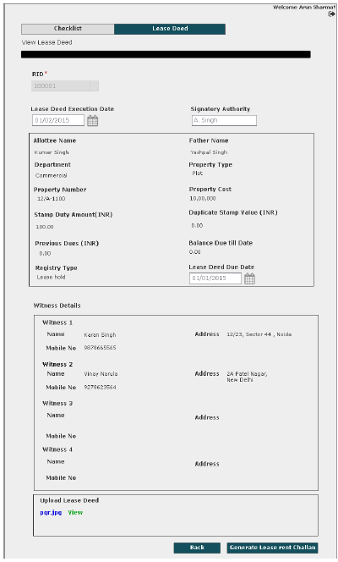

User Story – Generate Lease Rent Challan

Sprint | 4
User Story ID | 004
User Story Title | Generate Lease Rent Challan
Actors | Department user
Story | As a department user, I want to generate lease rent challan for particular registration ID.
Pre Conditions | - User should have required access rights.  - Printer should be connected to LAN.
Business Criteria | - Challan would contain lease rent amount in two individual heads:  - Previous Dues of lease rent  - Lease Rent (One Time/Current Year)  - Lease rent would be calculated as per below options:  First option, the allottee can pay the lease money every year. In this instance, lease money is defined percentage of property area multiplied by the current circle rate.  Second option, the allottee can pay lease rent of current year and multiply it with a certain number of years (as decided by the authority from time to time) and that would be considered as ONE TIME lease rent, which is equivalent to lease rent for entire lease duration of a defined time-frame.  In both cases allottee has to pay advance one year lease rent.  Formulas for reference:  [Per Year Lease Money= (PA*CR*PER)/100]  where,  PA=Property Area (Sq.mtr)  CR=Circle Rate  PER=Defined % by authority Rules  One time Lease Money=Per Year Lease Money*Define Year by authority  if late payment of lease rent,  Penal Interest = P*(1+r/100) ^ n  Where,  P = Principal (one year lease rent)  r = rate of interest  n = frequency
Acceptance Criteria | - User would click on “RID” hyperlink option available in grid for viewing the lease deed details.  - On the same page, user would click on “Generate Lease Rent Challan” button. A popup window would be displayed which would have the option to select type of lease rent challan as:  - One Time Lease Rent  - Annual Lease Rent  - The system would then generate and display the lease rent challan on the application screen.  - User would have the options to save the file to his local system by clicking on ‘Download’ button or print challan by clicking on ‘Print’ button.
Field level Validation

Mock-ups

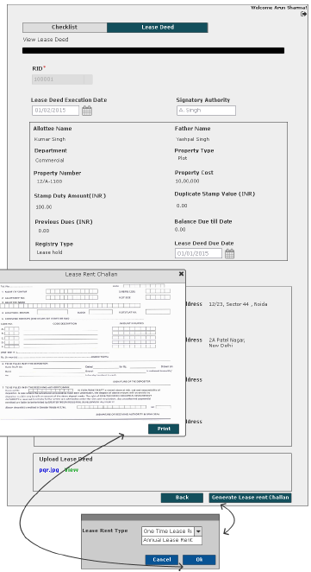

User Stories- Mutation Process

Mutation is to keep record of transfer of a property title from one person to another.

Add Mutation Request

Sprint | 4
User Story ID | 004
User Story Title | Add
Actors | Department user
Story | As a department user, I want to request for approval of Mutation a property, so that I can generate Mutation letter.
Pre Conditions | - User should have required access rights.
Business Criteria | - User would only be able submit Mutation request for his department.  - Mutation is done for transferred properties only.  - If a property has more than one transfer history then, its latest transfer details would be displayed and Mutation letter would be generated for the same.  - Manage Mutation would only contain the latest Mutation details for a Rid, in case a property has been recorded for multiple mutation.  - Once the request is submitted, a notification would be sent to approver for the same.  - Auto notifications will be sent to approver with an interval of 3 days, if a request is in progress for approval for more than 3 days.  - If a request is submitted to an approver but not actioned its status would be ‘pending’. Approved and rejected requests would have ‘approved’ and ‘rejected’ status respectively.  - If the request is cancelled by the department user, its status would be ‘cancelled’.
Acceptance Criteria | Navigation-> Manage Mutation Properties -> Add Request  - User would get a form which contain following fields:  - RID: drop down  - Based on this selection the following information would be displayed:  Applicant Information  - Property No.  - Scheme Name  - Department  - Applicant Name  - Gender  - Father’s Name  - Signing Authority (in case of company as gender)  - Registered Office (in case of company as gender)  - Property type  - Area  - Floor (in case of flats)  Transferee Information:  - Transferee Name  - Gender  - Father’s Name  - Signing Authority (in case of company as gender)  - Registered Office (in case of company as gender)  - Property type  - Area  - Floor (in case of flats)  - Transfer Date  - Transfer Type  - User would enter the following details  - Mutation Date: Date Picker, mandatory  - Transfer Deed Date: Date Picker, mandatory  - Bahi Number: Textbox, mandatory  - Bahi Zild Number: Textbox, mandatory  - Bahi Page Number: Textbox, mandatory  - SI. Number: Textbox , mandatory  - Upload Transfer Deed: Browse File, optional  - Once, user validates the information he would submit request by clicking on ‘Submit Request’ button.  - User would be given an option to choose the approver. User would select the approver name from the drop down and click ‘Submit’ button to submit the request.  - Alternatively, user would click on ‘back’ button to return to Manage Mutation menu without making any changes.  - After successful submission of request it would be displayed in a grid on manage Mutation properties page with following columns:  - Request No  - RID  - Department  - Property No  - Request date  - Mutation date (for approved entries)  - Status (Pending, cancelled, approved, rejected)
Field level Validation | - Bahi Number: Numeric, maximum 20 characters  - Bahi Zild Number: Numeric, maximum 20 characters  - Bahi Page Number: Numeric, maximum 20 characters  - SI. Number: Numeric, maximum 20 characters.  - Upload Transfer Deed: Image (jpg, png), maximum 100KB.  - Mutation Date cannot be less then Transfer Deed Date and Transfer Date.  - Transfer Deed Date cannot be less then transfer date.

Mock-ups

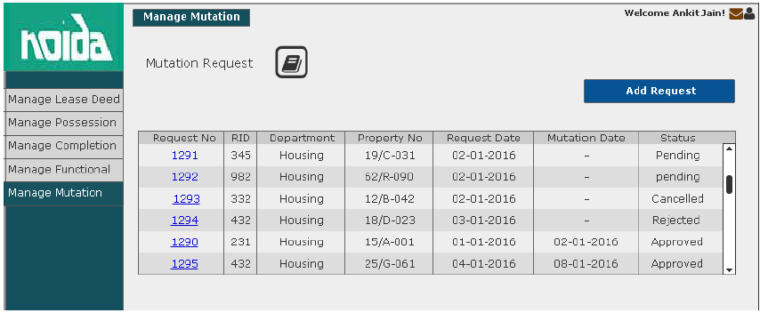
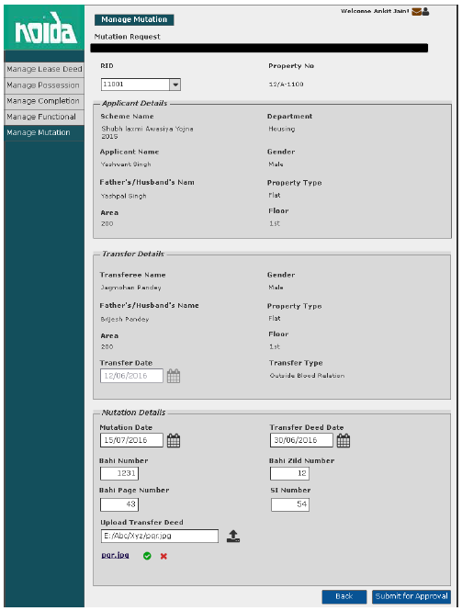
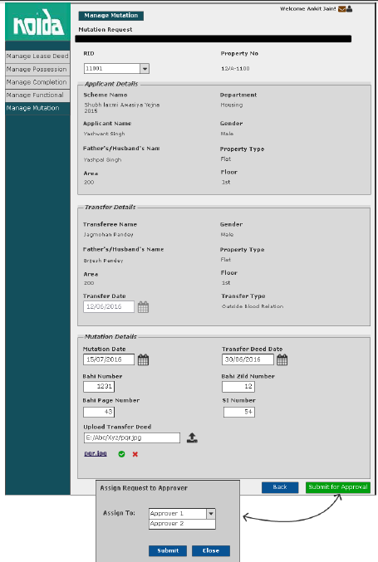

View Request- Department User

Sprint | 4
User Story ID | 002
User Story Title | View Request
Actors | Department User
Story | As a department user, I want to view submitted Mutation request of a property.
Pre Conditions | - User should have required access rights.
Business Criteria | - If request is submitted but not actioned by the approver then user would get ‘Cancel Request’ and ‘back’ button.  - If the request is rejected by the approver then user would get the option of ‘Resubmit Request’ and ‘View Comment’ along with ‘Back’ button  - For cancelled requests user would get the option to ‘resubmit Request’ and ‘Back’ button.  - If request is approved by the approver then user would get following options:  - Generate Mutation Letter  - View Comment  - Back
Acceptance Criteria | - User would click on a particular request no from the grid under manage Mutation properties menu  - User would get a screen which would display the following information:  - RID  - Scheme Name  - Department  - Property No  - Applicant Name  - Father/Husband Name  - Signing Authority (in case of company as gender)  - Registered Office (in case of company as gender)  - Property type  - Area  - Floor (In case of flats)  Transfer Information  - Transferee Name  - Father’s Name  - Gender  - Signing Authority (in case of company as gender)  - Registered Office (in case of company as gender)  - Property Type  - Area  - Floor (in case of flats)  - Transfer Date  - Transfer Type (Blood Relation/Outside Blood Relation)  - User would get Mutation details.  - Mutation Date  - Transfer Deed Date  - Bahi Number  - Bahi Zild Number  - Bahi Page Number  - SI. Number  - Upload Transfer Deed  - User would get different options based on the scenario( see Business Rules)
Field level Validation

Mock-ups

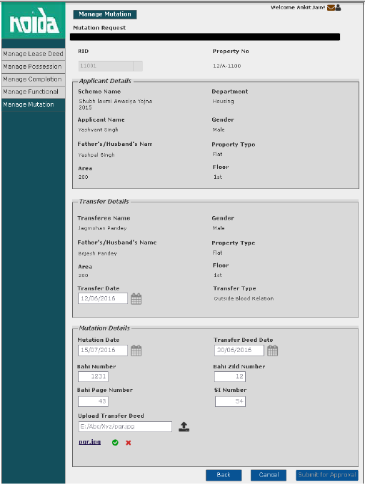
Request submitted for approval
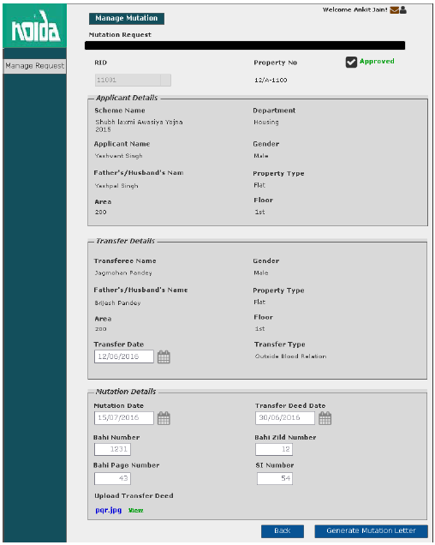
Approved Mutation Request
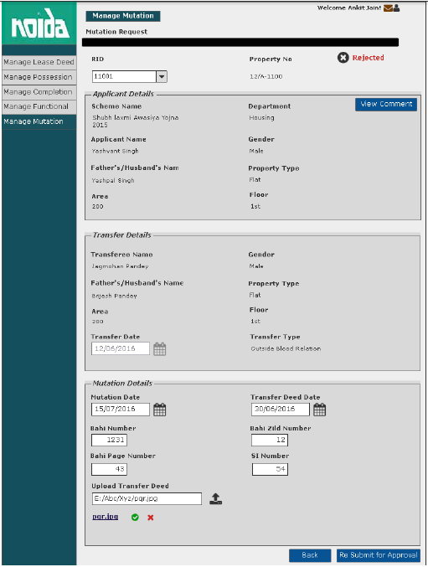
Rejected Mutation request

Cancel Mutation Approval request

Sprint | 4
User Story ID | 003
User Story Title | Cancel Mutation approval request
Actors | Department User
Story | As a department user, I want to cancel Mutation approval request of a property.
Pre Conditions | - User should have required access rights.
Business Criteria | - Only those request which are pending would be cancelled.
Acceptance Criteria | - User would click on a particular request from the grid under Manage Mutation menu.  - Request will be displayed and user would click on the ‘Cancel’ button to cancel the request.  - Alternatively, user would click on ‘Back’ button to return to the manage Mutation page without making any changes.
Field level Validation

Mock-ups

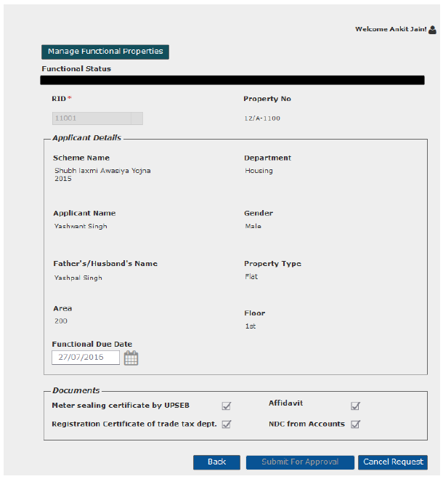

View Comment- Department User

Sprint | 4
User Story ID | 004
User Story Title | View Comment
Actors | Department user
Story | As a department user, I want to view comment on Mutation request
Pre Conditions | - User should have required access rights.
Business Criteria | - Only, approved/rejected request would contain the option to View comment.
Acceptance Criteria | Navigation: Manage Mutation -> Mutation Request -> View Comment  - User would click on ‘View Comment’ button on Mutation request screen.  - User would see a Popup window with the following information:  - Comment from  - Comment  - Comment Date  - If user needs to go back or cancel this screen, user would click on ‘Close’ button and the control will be directed to Mutation request screen.
Field Level Validation

Mock-ups
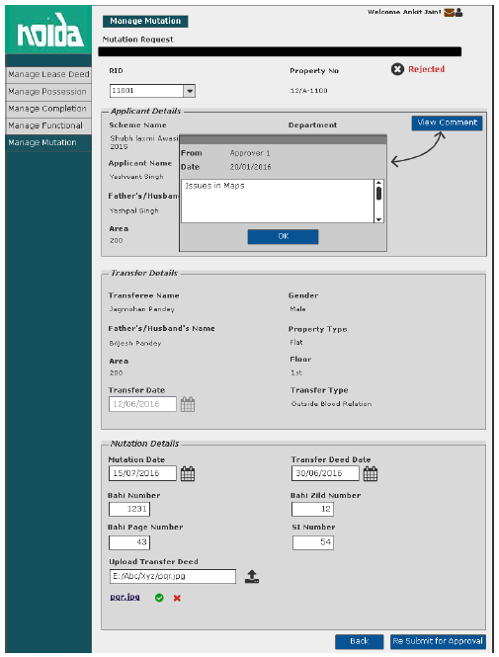

View Request- Approver

Sprint | 4
User Story ID | 005
User Story Title | View Request
Actors | Approver
Story | As an approver, I want to view submitted Mutation approval request of a property.
Pre Conditions | - User should have required access rights.
Business Criteria | - If the request is not actioned then, user would get ‘Approve’ and ‘Reject’ button along with ‘back’ button.  - If request is cancelled then, user would get ‘back’ button.  - If request is approved then, user would get ‘View Comment’ and ‘back’ button.  - If request is rejected then, user would get ‘View comment’, ‘Approve’ and ‘back’ button.
Acceptance Criteria | - User would click on ‘Mutation Request’ under ‘Manage request’ menu and get a grid which contain Mutation requests information with following columns:  - Request No  - RID  - Property No  - Request Date  - Approved Date  - Status (Pending/Approved/Rejected/Cancelled)  - User would click on a particular request from the grid under Manage Request menu  - User would get a screen which would display the following information:  - RID  - Scheme Name  - Department  - Property No  - Applicant Name  - Father/Husband Name  - Signing Authority (in case of company as gender)  - Registered Office (in case of company as gender)  - Property type  - Area  - Floor (In case of flats)  Transfer Information  - Transferee Name  - Father’s Name  - Gender  - Signing Authority (in case of company as gender)  - Registered Office (in case of company as gender)  - Property Type  - Area  - Floor (in case of flats)  - Transfer Date  - Transfer Type (Blood Relation/Outside Blood Relation)  - User would get Mutation details.  - Mutation Date  - Transfer Deed Date  - Bahi Number  - Bahi Zild Number  - Bahi Page Number  - SI. Number  - Upload Transfer Deed  - User would get different options based on the scenario( see Business Rules)
Field level Validation

Mock-ups
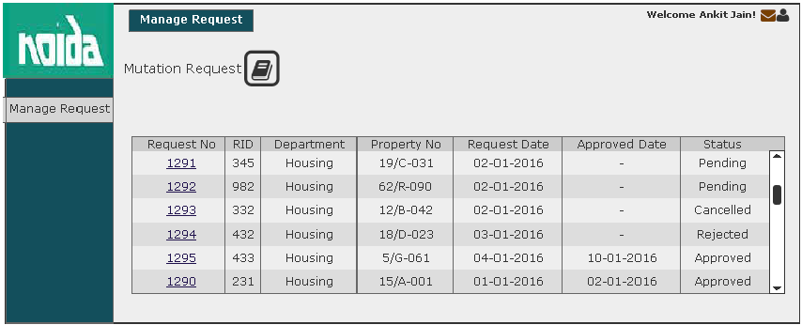

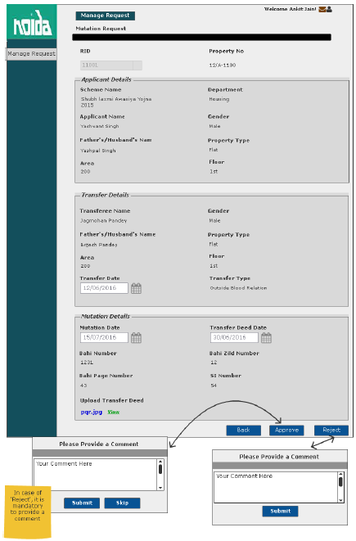
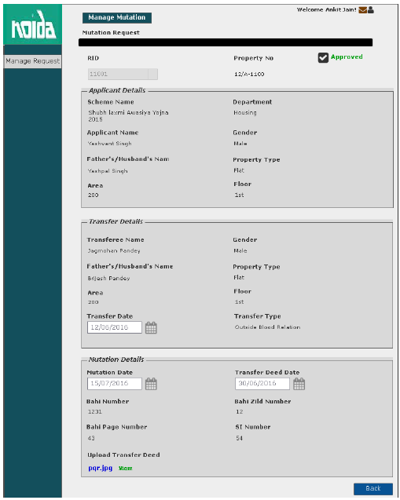
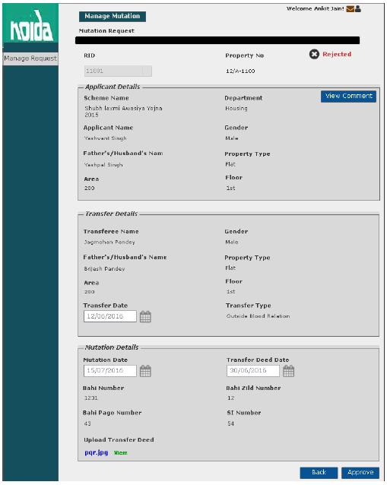

User Story- Approve/Reject Mutation approval Request

Sprint | 4
User Story ID | 006
User Story Title | Approve/Reject Mutation Approval request
Actors | Approver
Story | As an approver, I want to action Mutation request of a property so that I can Approve/Reject request.
Pre Conditions | - User should have required access rights.
Business Criteria | - Once a request is approved/rejected a notification would be send to initiator of the request.  - It is mandatory to provide a comment for rejecting a request.  - Rejected request can be approved again.  - It is mandatory to provide a comment when approving a rejected request.  - If a request is not actioned its status would be ‘pending’. Approved and rejected requests would have ‘approved’ and ‘rejected’ status respectively.  - If the request is cancelled by the department user, its status would be ‘cancelled’. Approver would not get any options to approve, reject for these requests.  - Requests with ‘Pending’ as Status column would always be displayed on top.
Acceptance Criteria | - User would click on ‘Mutation Request’ under ‘Manage request’ menu and get a grid which contain Mutation requests information with following columns:  - Request No  - RID  - Property No  - Request Date  - Approved Date  - Status (Pending/Approved/Rejected/Cancelled)  - User would click on a particular request from the grid under Manage Request menu  - User would get a screen which would display the following information:  - RID  - Scheme Name  - Department  - Property No  - Applicant Name  - Father/Husband Name  - Property type  - Area  - Floor (In case of flats)  Transfer Information  - Transferee Name  - Father’s Name  - Gender  - Property Type  - Area  - Floor (in case of flats)  - Transfer Date  - Transfer Type (Blood Relation/Outside Blood Relation)  - User would get Mutation details.  - Mutation Date  - Transfer Deed Date  - Bahi Number  - Bahi Zild Number  - Bahi Page Number  - SI. Number  - Upload Transfer Deed  - Under User would click on ‘Approve’ button to approve the request or ‘Reject’ button to reject the request.  - In both cases user would get a popup window to provide comment.  - In case of ‘Approve’ user would have a choice to provide comment or not however, in case of ‘Reject’ it is mandatory to provide comment.
Field level Validation | - Comment: Text, maximum 500 characters, mandatory in case of reject list.

Mock-ups

Resubmit request for Mutation Approval

Sprint | 4
User Story ID | 007
User Story Title | Resubmit request for Mutation Approval
Actors | Department User
Story | As a department user, I want to resubmit Mutation approval request of a property.
Pre Conditions | - User should have required access rights.
Business Criteria | - Only Cancelled and rejected requests would be resubmitted.  - Requested date would be updated on the grid.
Acceptance Criteria | - User would click on a particular request from the grid under ‘Manage Mutation Properties’ menu.  - Request will be displayed and user would click on the ‘Resubmit for Approval’ button to request again.  - Alternatively, user would click on ‘Back’ button to return to the manage Mutation page without making any changes.
Field level Validation

Mock-ups

View Comment- Approver

Sprint | 4
User Story ID | 008
User Story Title | View Comment
Actors | Department user
Story | As a department user, I want to view comment on Mutation request
Pre Conditions | - User should have required access rights.
Business Criteria | - Only, approved/rejected request would contain the option to View comment.
Acceptance Criteria | Navigation: Manage Request -> Mutation Request -> View Comment  - User would click on ‘View Comment’ button on Mutation request screen.  - User would see a Popup window with the following information:  - Comment from  - Comment  - Comment Date  - If user needs to go back or cancel this screen, user would click on ‘Close’ button and the control will be directed to Mutation order request screen.
Field Level Validation

Mock-ups
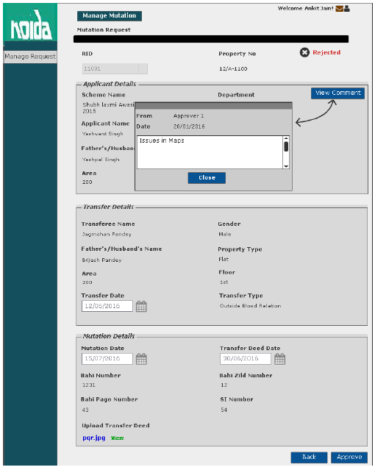

Generate Mutation Letter

Sprint | 4
User Story ID | 009
User Story Title | Generate Mutation Letter
Actors | Department user
Story | As a department user, I want to generate Mutation Letter
Pre Conditions | - User should have required access rights.
Business Criteria | - Only, approved request would contain the option to generate Mutation Letter.
Acceptance Criteria | - User would click on ‘Generate Mutation Certificate’ button on Mutation request screen.  - Mutation Letter would be displayed on a separate screen.  - User would print Mutation Letter by clicking on ‘Print’ button.
Field Level Validations

Mock-ups
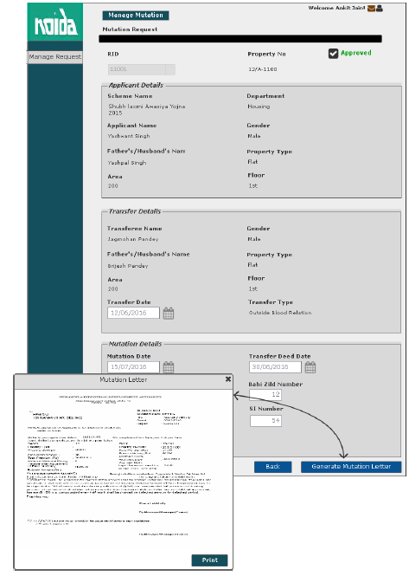

SMS/Email Notifications to allottee

Sprint | 4
User Story ID | 010
User Story Title | SMS/Email notifications to allottee
Actors | Allottee
Story | As an allottee I want system to send me SMS/email notifications for Mutation request
Pre Conditions | - User should have required access rights.
Business Criteria | - An SMS/Email notification would be send to allottee once, the request is submitted for Mutation.  - An SMS/Email notification would be send to allottee, if the request is cancelled.  - An SMS/Email notification would be send to allottee, if the request is rejected with comment.  - An SMS/Email notification would be send to allottee, if the request is approved, asking user to clear any dues in order to get Mutation letter.
Acceptance Criteria
Field Level Validations

